**ER diagram examples.**

**Example 1:**

•The airline has one or more airplanes.

• An airplane has a model number, a unique registration number, and the capacity to take one or more passengers.

• An airplane flight has a unique flight number, a departure airport, a destination airport, a departure date and time, and an arrival date and time.

• Each flight is carried out by a single airplane.

• A passenger has given names, a surname, and a unique email address.

• A passenger can book a seat on a flight.

**Probable Solution of Example 1:**

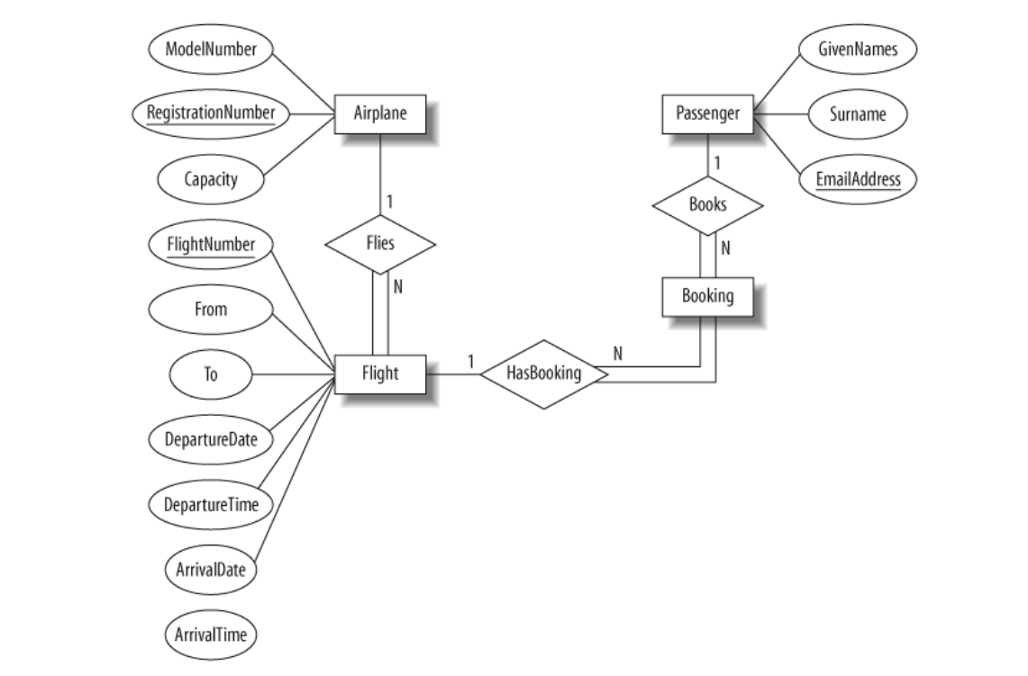

**Example 2:**

The university offers one or more programs. A program is made up of one or more courses. A student must enroll in a program. A student takes the courses that are part of her program. A program has a name, a program identifier, the total credit points required to graduate, and the year it commenced.A course has a name, a course identifier, a credit point value, and the year it commenced. Students have one or more given names, a surname, a student identifier, a date of birth, and the year they first enrolled. We can treat all given names as a single object—for example, “Roger Federer.” When a student takes a course, the year and semester he attempted it are recorded. When he finishes the course, a grade (such as A or B) and a mark (such as 60 percent) are recorded. Each course in a program is sequenced into a year (for example, year 1) and a semester (for example, semester 1).

**Probable Solution of Example 2:**

